VICTORIA JUNIOR COLLEGE
PRELIMINARY EXAMINATION

MATHEMATICS |  | 8864
(HIGHER 1)

 |  | SEPT 2012
 |  | 3 hours
Additional materials: | Answer paper  List of Formulae (MF15)

READ THESE INSTRUCTIONS FIRST

Write your name and CT group on all the work you hand in.
Write in dark blue or black pen on both sides of the paper.
You may use a soft pencil for any diagrams or graphs.
Do not use staples, paper clips, highlighters, glue or correction fluid.

Answer all the questions.
Give non-exact numerical answers correct to 3 significant figures, or 1 decimal place in the case of angles in degrees, unless a different level of accuracy is specified in the question.
You are expected to use a graphic calculator.
Unsupported answers from a graphic calculator are allowed unless a question specifically states otherwise.
Where unsupported answers from a graphic calculator are not allowed, you are required to present the mathematical steps using mathematical notations and not calculator commands.
You are reminded of the need for clear presentation in your answers.

At the end of the examination, fasten all your work securely together.
The number of marks is given in brackets [ ] at the end of each question or part question.

This document consists of 5 printed pages.
© VJC 2012 | VICTORIA JUNIOR COLLEGE | [Turn over

Section A: Pure Mathematics (35 marks)

- Find, algebraically, the smallest value of the integer k for which 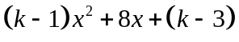 is always positive for all real values of x. [5]

- Without using a calculator, solve the simultaneous equations
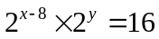 and 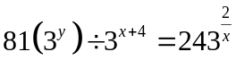. [6]

- The diagram shows a rectangular piece of cardboard ABCD of dimensions h cm by w cm. The total area of the cardboard is 630 cm². A rectangle PQRS is cut out in the middle such that the cardboard is now left with 2 cm margins on the left and right, a 3 cm margin on top and a 2.5 cm margin at the bottom as shown.
A
B
C
D
h cm
w cm
2 cm
2 cm
3 cm
cm
P
Q
R
S

P
Q

R
S

(i) If A is the area of PQRS, show that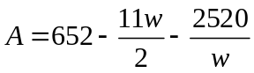. [3]
(ii) Find, using differentiation, the dimensions of the cardboard for which A is maximum. [4]

- Find the equations of the asymptotes of the graph
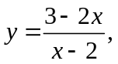
and sketch the graph. [3]

On the same diagram, sketch the graph of 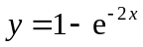. [2]

Hence, find the numerical value of the area of the region enclosed between the two curves. [3]

- (a) Given that 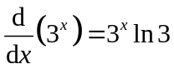, find 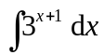. [2]

(b) Find the exact value of 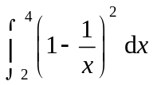, expressing your answer in the form 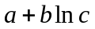, where a, b and c are constants to be determined. [4]

Hence find the value of p such that 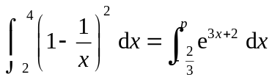, leaving your answer
correct to two decimal places. [3]

Section B: Statistics (60 marks)

- The masses of yoghurt bars produced by a factory are distributed with a mean mass of 20.1g and a standard deviation of 3g. A random sample of n bars is taken every day for testing.

Given that the standard deviation of the distribution of the sample mean is , find the value of n.
[2]

Find the probability that the sample mean exceeds 21g. [2]

State, giving a reason, whether any assumptions or approximations have been used in the calculation of the above probability. [2]

- Given that 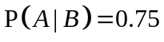, 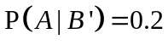 and 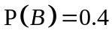, find
(i) 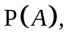 [3]
(ii) 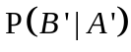. [2]

The events A and C are independent and are such that 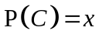 and 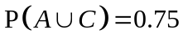. Find x.
[3]

- In a large international school, 64% of its staff members own a car.

(i) Find the probability that, in a random sample of 25 staff members, at least 15 of them own a car. [2]

(ii) The probability that there is at least one staff member who own a car out of a random sample of n staff member is greater than 0.97. Find the least value of n. [4]

(iii) Use a suitable approximation to estimate the probability that, in a group of 200 randomly chosen staff members, more than 110 but not more than 130 staff members own a car. You should state the mean and variance of the distribution used in the approximation. [4]

[Turn Over
- The thickness in mm of a Statistics textbook is a random variable with the distribution 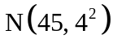. The thickness in mm of a Calculus textbook is a random variable with the distribution N(25, 3²).

Find the probability that

(i) the average thickness of three randomly chosen Calculus textbook is less than 22 mm, [2]

(ii) the total thickness of two randomly chosen Statistics textbook is at least 30 mm thicker than two times the thickness of one randomly chosen Calculus textbook. [4]

A particular bookshop plans to stock up on n Statistics textbooks. Show that to achieve at least 96% chance of fitting these n textbooks onto a bookshelf of length 1 m, then n must satisfy the inequality
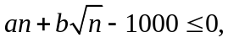
where a and b are constants to be determined. [5]

- Salt is packed in bags which the manufacturer claims weigh on average 25kg per bag. A random sample of 80 bags is examined and the mass, x kg, of the contents of each bag is determined. It is found that
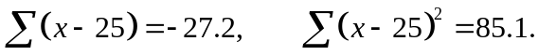

(i) Find unbiased estimates of the population mean and variance of X. [3]

(ii) Test, at the 1% level of significance, whether the manufacturer’s claim is incorrect.

State, giving a reason, whether it is necessary to make any assumptions about the distribution of the mass of the contents of a bag for the test to be valid. [5]

(iii) Explain, in the context of the question, the meaning of “1% level of significance”. [1]

(iv) Without any further calculations, explain if it is necessarily true to conclude, at the 1% significance level using the same sample, that there is sufficient evidence that, on average, each bag contains less than 25kg of salt. [2]

- The data in the table below shows the temperature, t ºC, of the shoulder of the tyre of a car at eight different fixed values of the speed, v km h⁻¹. The car is driven under specific conditions of load, tyre pressure and surrounding temperature.

v | 20 | 30 | 40 | 50 | 60 | 70 | 80 | 90
t | 45 | 52 | 64 | 101 | 72 | 86 | 98 | 104

(i) Give a sketch of the scatter diagram for the data. One of the values t appears to be incorrect. Indicate the corresponding point on your diagram by labelling it P. [3]

The data pair corresponding to P is removed from the data set.

(ii) Calculate the product moment correlation coefficient, and comment on its value in the context of this question. [3]

(iii) Calculate the equation of an appropriate regression line and use it to estimate the value of v when 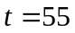. Comment briefly on the reliability of the estimate. [4]

(iv) A student makes this observation: “When the car is driven at a higher speed, it causes the temperature of the shoulder of the tyre to increase.” State, with a reason, whether you agree with the student’s remark. [1]

It was later found that the temperature at speed 50 km h⁻¹ was recorded wrongly, and the correct table is given as follows:

v | 20 | 30 | 40 | 50 | 60 | 70 | 80 | 90
t | 45 | 52 | 64 | k | 72 | 86 | 98 | 104

The equation of the regression line of t on v is 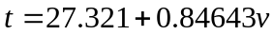.

Find k correct to the nearest integer. [3]

END OF PAPER

